Bootstrap worksheet

Sajith Gowthaman (ek5282))

2/8/2020

Ques 1: a) How many possible bootstrap resamples of these data are there?

choose(23,12)

## [1] 1352078

# 1352078 possible bootstrap resamples are there

b)Using R and the sample() function, or a random number table or generator, generate five resamples of the integers from 1 to 12.

Org_data<-c(4.94,5.06,4.53,5.07,4.99,5.16,4.38,4.43,4.93,4.72,4.92,4.96)  
B_Sample1<-sample(Org_data,1:12,replace = TRUE)  
B_Sample2<-sample(Org_data,1:12,replace = TRUE)  
B_Sample3<-sample(Org_data,1:12,replace = TRUE)  
B_Sample4<-sample(Org_data,1:12,replace = TRUE)  
B_Sample5<-sample(Org_data,1:12,replace = TRUE)

c)For each of the resamples in b, find the mean of the corresponding elements of the aflatoxin data set. Print out the 5 bootstrap means.

mean(Sample1)

## [1] 4.92

mean(Sample2)

## [1] 5.16

mean(Sample3)

## [1] 4.38

mean(Sample4)

## [1] 4.92

mean(Sample5)

## [1] 4.92

d)Find the mean of the resample means. Compare this with the mean of the original data set.

R_Mean<-c(Sample1,Sample2,Sample3,Sample4,Sample5)  
mean(ResampleMean)

## [1] 4.86

mean(org_data)

## [1] 4.840833

e)Find the minimum and the maximum of the five resample means. This a crude bootstrap confidence interval on the mean.

min(R_Mean)

## [1] 4.38

max(R_Mean)

## [1] 5.16

Ques2: a)For the sample data, compute the mean and its standard error and the median

Airline_Accident<-c(23, 16, 21, 24, 34, 30,28, 24, 26, 18, 23, 23, 36, 37, 49, 50, 51, 56, 46, 41, 54, 30, 40,31)  
mean(AirlineAccident)

## [1] 33.79167

sd(AirlineAccident)

## [1] 12.06497

median(AirlineAccident)

## [1] 30.5

1. Compute bootstrap estimates of the mean, median and 25% trimmed mean with estimates of their standard errors, using B = 1000 resamples.

bs_mean=NULL  
bs_median=NULL  
B=1000  
 set.seed(1)  
 for (i in 1:B) {  
 bs_AirlineAccident=sample(AirlineAccident,1:24,replace = TRUE)   
 bs_mean[i]=mean(bs_AirlineAccident)

bs_median[i]=median(bs_AirlineAccident)   
 }  
 mean(bs_mean)

## [1] 33.495

median(bs_median)

## [1] 30

mean(bs_mean, trim = .25)

## [1] 31.666

sd(bs_mean)

## [1] 11.52635

sd(bs_median)

## [1] 11.52635

par(mfrow=c(1,1))  
hist(bs_mean,xlab = "No.of AirlineAccident", ylab = "Frequency",col = "red")

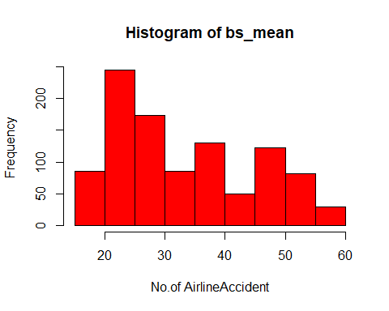

hist(bs_median,xlab = "No.of AirlineAccident", ylab = "Frequency",col = "blue")

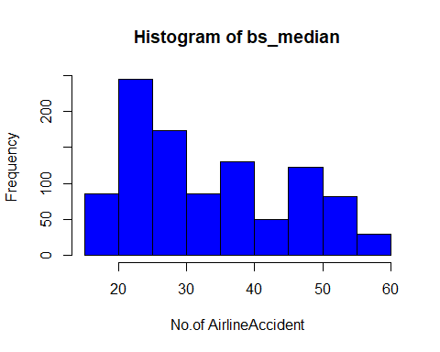

1. Compare parts a and b. How do the estimates compare? # In part a), it returns the average and median of the airline accidents, whereas in part b) apart from the average airline accident and median value, it also shows the 25% trimmed mean of the accident.

Ques3: Consider a population that has a normal distribution with mean µ = 36, standard deviation σ = 8. a) The sampling distribution of 𝑋̅ for samples of size 500 will have what distribution, mean and standard error?

ans: For this question, it will be normally distributed with a sample of size 500, mean = 36, and std. error = 8/sq.root(500).

b)Use R to draw a random sample of size 500 from the population. Conduct exploratory data analysis on your sample

set.seed(4)   
a=rnorm(500,36,8)   
mean(a)

## [1] 35.76682

sd(a,na.rm = FALSE)

## [1] 7.751093

sd(a)/sqrt(500)

## [1] 0.3466394

hist(a)  
abline(v=mean(a), col="red", lty=2)

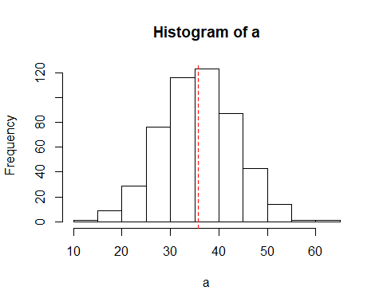

c)Compute the bootstrap distribution for your sample and note the bootstrap mean and standard error

B=10^4  
bs_1=NULL  
  
set.seed(1000)

for (i in 1:B) {  
 bs1=sample(a,500, replace = TRUE)  
 bs_1[i]= mean(bs1)  
}  
mean(bs_1)

## [1] 35.76719

sd(bs_1)

## [1] 0.3487043

hist(bs_1)  
abline(v=mean(bs_1), col="red", lty=2)

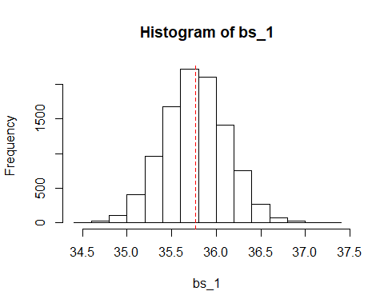 d) #Dist #Mean #std.dev #Population 36 8 #Sampling dist 36 8 #Sample 35.76 7.75 #Bootstrap sample 35.76 0.34

e)Repeat for sample of sizes n = 50 and n = 10. Carefully describe your observations about the effects of sample size on the bootstrap distribution.

bs_50=NULL  
set.seed(100)  
for (i in 1:B) {  
bs50=sample(a, 50, replace=T)  
bs_50[i]=mean(bs50)  
}  
mean(bs50)

## [1] 33.92609

sd(bs50)

## [1] 7.831231

hist(bs50)

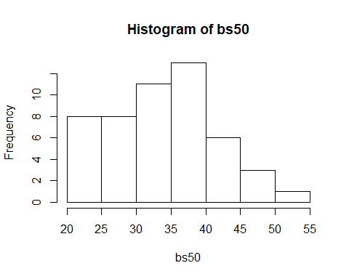

bs_10=NULL  
set.seed(11)  
for (i in 1:B) {  
bs10=sample(a, 10, replace=T)  
bs_10[i]=mean(bs10)  
}  
mean(bs10)

## [1] 31.96081

sd(bs10)

## [1] 7.226446

hist(bs10)

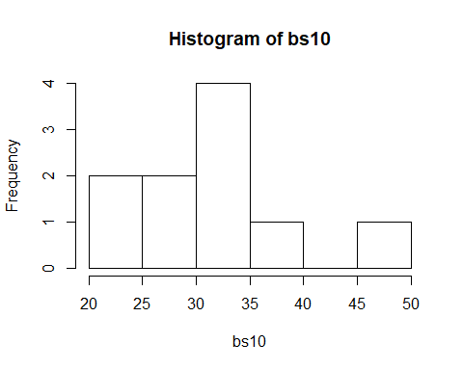

Ques4: a)

(6/8+5/8+5/8+5/8+7/8+4/8)/6

## [1] 0.6666667

b)Write out the R code to generate data of 100 parametric bootstrap samples and compute an 80% percentile confidence interval for θ.

set.seed(10)  
x_binomial=rbinom(100,8,(2/3))  
bs_binomial=NULL  
  
for (i in 1:B) {  
 bs_sample=sample(x_binomial,100, replace = TRUE)  
 bs_binomial[i]=mean(bs_sample)  
}  
  
quantile(bs_binomial,c(0.1,0.8))

## 10% 80%   
## 5.18 5.43

80% percentile confidence interval for θ is between 5.179 and 5.432

Ques 5: a)Propose a parametric approach to answer this question. Mention clearly all assumptions for such an approach

Ans: Lets conduct a hypothesis test and then conduct a T-test to find if there is a significant difference by evaluating the value of P. p-value>0.05. F

Fail to reject the hypothesis.

Full_time<-c(28, 23, 18, 16, 15, 15, 13, 31, 31)  
student<-c(9, 11, 14, 14, 16, 19, 37)  
t.test(Full_time, student , var.equal = T)

##   
## Two Sample t-test  
##   
## data: Full_time and student  
## t = 0.95805, df = 14, p-value = 0.3543  
## alternative hypothesis: true difference in means is not equal to 0  
## 95 percent confidence interval:  
## -4.915511 12.852019  
## sample estimates:  
## mean of x mean of y   
## 21.11111 17.14286

1. We fail to reject the hypothesis.

B=10^4  
diff_mean=numeric(B)  
for(i in 1:B)  
{  
fl.sample=sample(Full_time_prof, 9, T)  
gt.sample=sample(Grad_student, 7, T)  
diff_mean[i]=mean(fl.sample)- mean(gt.sample)  
}  
hist(diff_mean)  
abline(v=mean(Full_time_prof)-mean(Grad_student), col="red", lty=2)

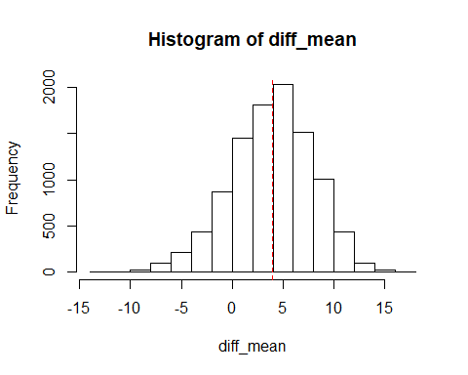

quantile(diff_mean, c(0.025, 0.975))

## 2.5% 97.5%   
## -4.555556 11.031746